Colorado Springs, Colorado |  |  | Monday, September 9, 2019
Fifth Annual Rocky Mountain Lions Eye Bank and Tri-Lakes Lions Golf Tournament
Recently named the top golf course in the Department of Defense by Travel and Leisure Golf Magazine. The Championship Blue was designed by Robert Trent Jones and measures more than 7,300 yards from the championship tees, 6,516 from the regular tees and 5,559 from the forward tees.  Parade Loop, Bldg 3170  Colorado Springs, CO 80840  Phone: (719) 333-2606  Monday, September 9, 2019  Cost: $135 donation per player  (A portion is tax deductible)  Registration opens 11:00 am  Lunch 11:30 pm  Shotgun start 1:00 pm  - On-Line Silent Auction  - Awards and Prizes  - Challenges  - Longest Putt  - Longest Drive  - Closest to the Pin  - Multiple Holes-in-One  - $100,000 SuperTicket Hole-in-One Shoot-Out  - Mulligans  For More Information Please Call:  Jim Naylor, 303-883-8329  Dave Prejean, 719-434-7031  Stan Krol, 720-339-3391 |  | Blue Course, U.S. Air Force Academy  4-Player Scramble  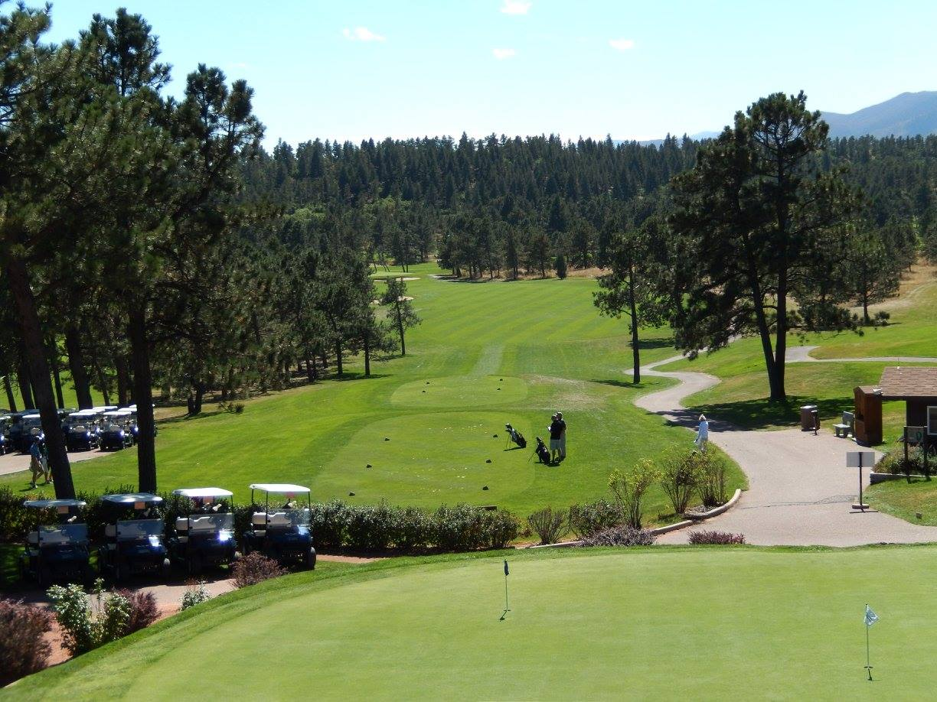  The fifth annual tournament will be held Monday, September 9th at USAFA, Blue Course in Colorado Springs. All proceeds from the tournament help support the following charities: Rocky Mountain Lions Eye Bank, fulfills the wishes of eye donors and their families to help others overcome blindness through transplantation and research with over 2500 sight-restorative transplants each year. Lions KidSight Screening, has a mission to provide free vision screening to kids six months to six years - over 54,000 Colorado children screened in 2016-2017. The Colorado Lions Camp, a year-round facility providing programs for those with developmental and physical disabilities. Tri-Lakes CARES, a community based, volunteer supported, resource center whose purpose is to improve lives through emergency, self-sufficiency, and relief programs.  To help us properly plan for this event, please complete the registration form on the reverse of this page and return to Tri-Lakes Lions Club, P. O. Box 164, Monument, CO 80132. Payment can be made now via credit card, or at registration. If you are sending a check now, please make payable to Tri-Lakes Lions Club. Donation covers green fees, cart, range balls, lunch, plus prizes.  Registration Form on Reverse of this Page

GOLF TOURNAMENT REGISTRATION FORM

Date: September 9, 2019
Time: Registration opens at 11:00 am. Lunch 11:30 pm. Shotgun start at 1:00 pm.
Place: U.S. Air Force Academy, Blue Course
Parade Loop, Building 3170
Colorado Springs, CO 80840
Phone: 719-333-2606

Entry Fee: $135.00 per player. Included are green fees, cart, range balls, lunch, plus prizes.
Registration
Deadline: September 2, 2019

Format: 4-Player Scramble

TO REGISTER, PLEASE CONTACT “JIM NAYLOR”:

(719) 481-8741 / (303) 883-8329 (719) 487-0950 jim1947n@comcast.net

Tri-Lakes Lions, P. O. Box 164, Monument, CO 80132

Players:
Team Captain _____________________________ Player 3 __________________________________
Phone Number _____________________________ Phone Number _____________________________
Email ____________________________________ Email ____________________________________

Player 2 __________________________________ Player 4 __________________________________
Phone Number _____________________________ Phone Number _____________________________
Email ____________________________________ Email ____________________________________

☐ Player(s) # _____ x $135/player = _______

☐ Check payable to Tri-Lakes Lions Club
☐ Visa ☐ M/C Billing Zip Code ___________
Card number ___________________________
Expires _________3-digit CID Code_________
Name on Card________________________________________________________
Signature_____________________________________________________________

Men’s proper attire is slacks or full-length walking shorts (no more than 3 inches above the knee) and a golf shirt or sport shirt. Ladies are asked to wear skirts or Bermuda length shorts, sport blouses or shirts, slacks or walking shorts (no more than 3 inches above the knee). Eisenhower Golf Course is a soft-spikes only facility
El Paso County Tri-Lakes Lions Club, P.O Box 164, Monument, CO 80132

