Monument, Colorado |  |  | Friday, August 20th, 2021
Eighth Annual Rocky Mountain Lions Eye Bank and Tri-Lakes Lions Golf Tournament
The Country Club at Woodmoor features an 18-Hole Championship J. Press Maxwell design golf course known for its natural beauty and its long, treelined, narrow fairways and elevated greens.  Golfers will find one of the most beautiful and challenging courses on the front range sitting atop the continental divide when they take a swing at 7400 ft above sea level.  18945 Pebble Beach Way  Monument, CO 80132  Phone: (719) 481-2272  Friday, August 20th, 2021  Cost: $140 donation per player  Registration opens 7:30 am  Shotgun start 8:30 am  Lunch 1:00 pm  - Silent Auction  - Awards and Prizes  - Challenges  - Longest Putt  - Longest Drive  - Closest to the Pin  - Multiple Holes-in-One  - $100,000 SuperTicket Hole-in-One Shoot-Out  - Mulligans  For More Information Please Call:  Jim Naylor, 303-883-8329  Dave Prejean, 719-434-7031  Stan Krol, 720-339-3391 |  | The Country Club at Woodmoor  4-Player Scramble  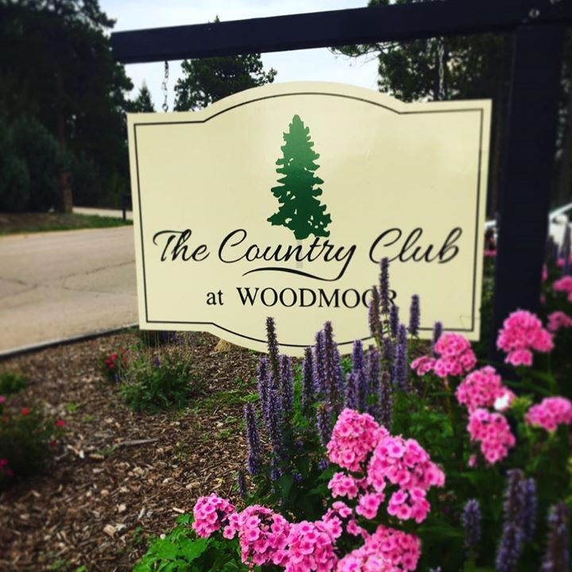  The eighth annual tournament will be held Friday, Aug 20th at 8:30am at Country Club of Woodmoor. All proceeds from the tournament help support the following charities: Rocky Mountain Lions Eye Bank, fulfills the wishes of eye donors and their families to help others overcome blindness through transplantation and research with over 2500 sight-restorative transplants each year. Lions KidSight Screening has a mission to provide free vision screening to kids six months to six years - over 46,000 Colorado children screened annually. The Colorado Lions Camp, a year-round facility providing programs for those with developmental and physical disabilities. Tri-Lakes CARES, a community based, volunteer supported, resource center whose purpose is to improve lives through emergency, self-sufficiency, and relief programs.  To help us plan for this event, please complete the registration form on the reverse of this page and return to Tri-Lakes Lions Club, P. O. Box 164, Monument, CO 80132. Payment can be made now via credit card, or at registration. If you are sending a check now, please make payable to Tri-Lakes Lions Club. Donation covers green fees, cart, range balls, lunch, plus prizes.  Registration Form on Reverse of this Page

GOLF TOURNAMENT REGISTRATION FORM

Date: August 20th, 2021
Time: Registration opens at 7:30 am. Shotgun start at 8:30 am. Lunch 1:00 pm.
Place: Country Club at Woodmoor
18945 Pebble Beach Way
Monument, CO 80132
Phone: 719-481-2272

Entry Fee: $140.00 per player. Included are green fees, cart, range balls, lunch, plus prizes.
Registration
Deadline: August 14th, 2021

Format: 4-Player Scramble

TO REGISTER, PLEASE CONTACT “JIM NAYLOR”:

(719) 481-8741 / (303) 883-8329 jim1947n@comcast.net

Tri-Lakes Lions, P. O. Box 164, Monument, CO 80132

Players:
Team Captain _____________________________ Player 3 __________________________________
Phone Number _____________________________ Phone Number _____________________________
Email ____________________________________ Email ____________________________________

Player 2 __________________________________ Player 4 __________________________________
Phone Number _____________________________ Phone Number _____________________________
Email ____________________________________ Email ____________________________________

☐ Player(s) # _____ x $140/player = _______

☐ Check payable to Tri-Lakes Lions Club
☐ Visa ☐ M/C Billing Zip Code ___________
Card number ___________________________
Expires _________3-digit CID Code_________
Name on Card________________________________________________________
Signature_____________________________________________________________

Men’s proper attire is slacks or full-length walking shorts (no more than 3 inches above the knee) and a golf shirt or sport shirt. Ladies are asked to wear skirts or Bermuda length shorts, sport blouses or shirts, slacks or walking shorts (no more than 3 inches above the knee). Woodmoor Country Club Golf Course is a soft-spikes only facility

El Paso County Tri-Lakes Lions Club, P.O Box 164, Monument, CO 80132

